1. Agenda:
   1. Create a service class containing business logic for our Products Microservice.
2. Before creating Service Class, let’s create Interface.
3. 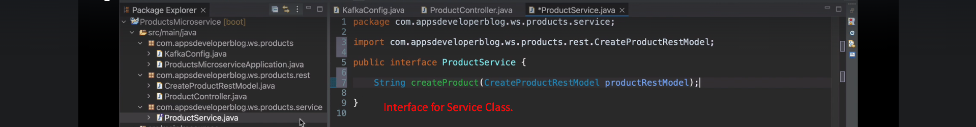
4. 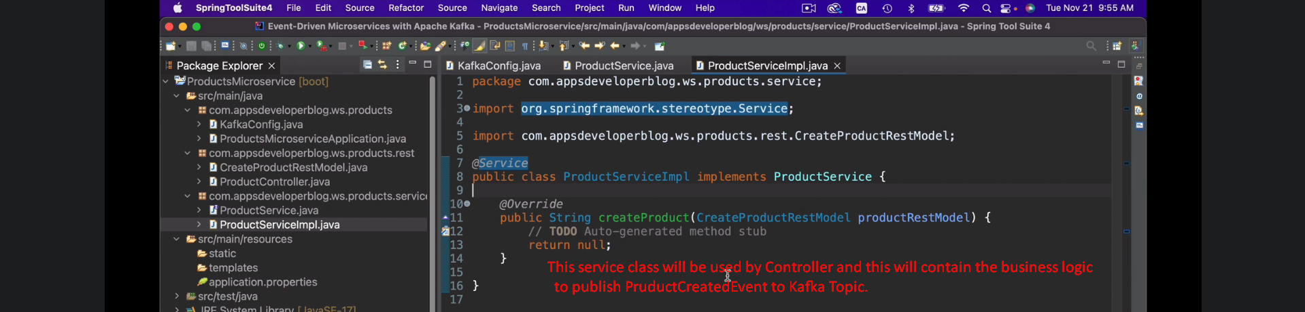
5. 